AUTHOR PROJECT CONFIRMATION FORM

Thank you for choosing AP Editorial & Publishing Services.

- This form is designed to be completed electronically in Microsoft Word (.doc/.docx) for best compatibility and functionality.
- The information helps us get to know you and where you are in the process of your book project before the first consultation.
- Once you have submitted this completed form, we will contact you to discuss the next steps.
- Email your complete form to publishing@amandapool.co.za

Please complete all the sections as accurately as possible.

AUTHOR DETAIL
Full Name and Surname:

Cell Number:

Email Address:

Postal/Delivery Address:

MANUSCRIPT SUBMISSION STATUS
To be completed by the author - INDICATE YOUR ANSWER WITH AN X
Choose the best descriptions of your manuscript you want to send:
____ First Draft? - (Initial manuscript with limited or no editing)
____ Self-Edited Draft ?- (Author has already revised spelling, grammar, and structure)

LANGUAGE OF MANUSCRIPT:
____ Afrikaans
____ English

PLEASE NOTE :

All manuscripts with AI-generated or AI-assisted content must meet editorial standards, including originality, attribution, ethics, and copyright. Additional reviews may be used to verify accuracy and compliance. Some AI-generated material may be subject to additional review requirements or publishing restrictions.

PLEASE INDICATE BELOW:
_ AI-Assisted and/or _ AI-Generated?

SERVICES REQUIRED
Please indicate the services you require.

EDITORIAL SERVICES
___ Proofreading (final spelling, punctuation and grammar corrections)
___ Language Editing (improving sentence structure, readability and language flow)
___ Structural Editing (reviewing chapter flow, content structure and overall organisation)

INTERIOR PREPARATION & LAYOUT
____ Manuscript Formatting & Page Preparation
____ Print-ready PDF Preparation

ISBN SUPPORT
____ ISBN & Barcode Placement

PRINTING
PLEASE INDICATE which is applicable

____ AP Editorial & Publishing Services to assist with printing
____ Author wants to arrange own printing
____ Unsure – discuss during consultation

Size of your book
___A4
___A5
___ Unsure – discuss during consultation
COVER PAGES
____ Do you want us to design your cover pages?
IF SO, we'll continue to work together closely, incorporating your ideas, pictures, photos, and more to make everything just right.
____ Unsure – discuss during consultation

DOES YOUR BOOK HAVE A TITLE YET? If so, please state the title
______________________________________________________________________________________________________________________________________________________________
The options of colour, binding type, etc, will be discussed during our first consultation

COPIES OF PRINTED BOOKS needed:
____ 50 minimum
____ 100
____ Other: ______________________

OUR TERMS & CONDITIONS

MANUSCRIPTS:
- ONLY Microsoft Word format (.doc or .docx).
- PDF manuscripts are not accepted for editing.
- Manuscript layout should already be prepared in the layout you prefer (A4 or A5)
WHEN QUOTING FROM ANY BIBLE TRANSLATION:
- Different Bible translations may be subject to copyright regulations and quotation limitations.
- Where applicable, authors remain responsible for ensuring compliance with the permissions and acknowledgements for the relevant Bible translation.
- © The relevant Bible translation used will be mentioned in the Copyright paragraphs. If unsure, this can be discussed during consultation.
TRACK CHANGES
All editing, proofreading, formatting suggestions, and corrections will be indicated using Microsoft Word Track Changes, Comments, or Reviewing Tools where applicable.
Authors will be requested to:
- Review all tracked changes carefully
- Respond to comments where clarification is required
- Accept or reject changes before final approval
- Where possible, use the same review tools when returning revised manuscripts to AP Editorial & Publishing Services.
We offer support:
If you are unfamiliar with Microsoft Word’s Track Changes or commenting features, we can provide support beforehand to ensure smooth communication and manuscript review.

YOUR TIMELINE EXPECTATION
Desired completion date:___________

Example: 6-8 weeks - to be discussed during the consultation

EXPECTED EDITORIAL WORKFLOW
- Receipt of author information form
- Consultation in person/online
- Quotation & Service Agreement
- Author to accept Quotation
- Author pays 50% non-refundable deposit upfront
- Editorial Review with Track Changes
- Author Review & Feedback
- Final Corrections
- Formatting & Publication Preparation
- Print/PDF/eBook Finalisation

AUTHOR APPROVAL
I hereby confirm that the above information is correct to the best of my knowledge.
I understand the EDITORIAL WORKFLOW
I confirm and accept the TERMS & CONDITIONS mentioned in this form.
I understand that I (the author) will sign off on the final WORD version before the book is printed.
The author may request a printed proof book upfront. Terms and Conditions apply.

FULL NAME:

SIGNATURE:

DATE:

FOR OFFICE USE ONLY
Quotation Number: _____________________________
Project Reference: ______________________________
Deposit Paid: ________________________________
Project Start Date: _____________________________
Project expected end date: _______________________

AUTHOR ONLINE PRESENCE

If you choose to make use of this service, please click below:

Yes, I want to make use of this service :
____ A one-page e-commerce website

This provides authors with a professional online presence to showcase their book, share their story and sell directly to readers. It also creates an easy, additional direct sales channel for your book and author brand.
The package includes:
- One-page e-commerce website
- Mobile-friendly design
- Book highlight section
- Author biography and contact section
- Hosting and email setup for 12 months
If extra pages are requested, , additional content or custom functionality will be quoted separately.

EXAMPLE OF AUTHOR ONLINE PRESENCE - see next page
_______________________________________________________________________________

HOME | ABOUT | BOOKS | BLOG | CONTACT

ABOUT THE AUTHOR
An author platform may include a short biography, ministry or business background, personal testimony, writing journey, and contact information.
This helps readers connect personally with the author and their message.

WHAT THE WEBSITE MAY INCLUDE
□ Professional one-page website
□ Mobile-friendly design
□ Book showcase section
□ Online ordering functionality
□ Author biography section
□ Contact and enquiry form
□ Social media integration
□ Blog or article section
□ Podcast, radio, or interview references
□ Email setup and hosting

BOOK SHOWCASE EXAMPLE
TITLE of the BOOK: _______________________________________________
AUTHOR Name Here: _____________________________________________

Description of the content of the book and a message from the AUTHOR
- Picture of the book's cover page
- PRICING: Rxxx Print Edition | Rxxx eBook (PDF) | Amazon link
- ORDER: WHATSAPP number
  - This page will enable readers to connect directly with the author •
    - WhatsApp or email enquiries
• Social media engagement
• Blog updates and articles
• Ministry or speaking invitations
• Newsletter or email communication

EXAMPLE of a possible layout:
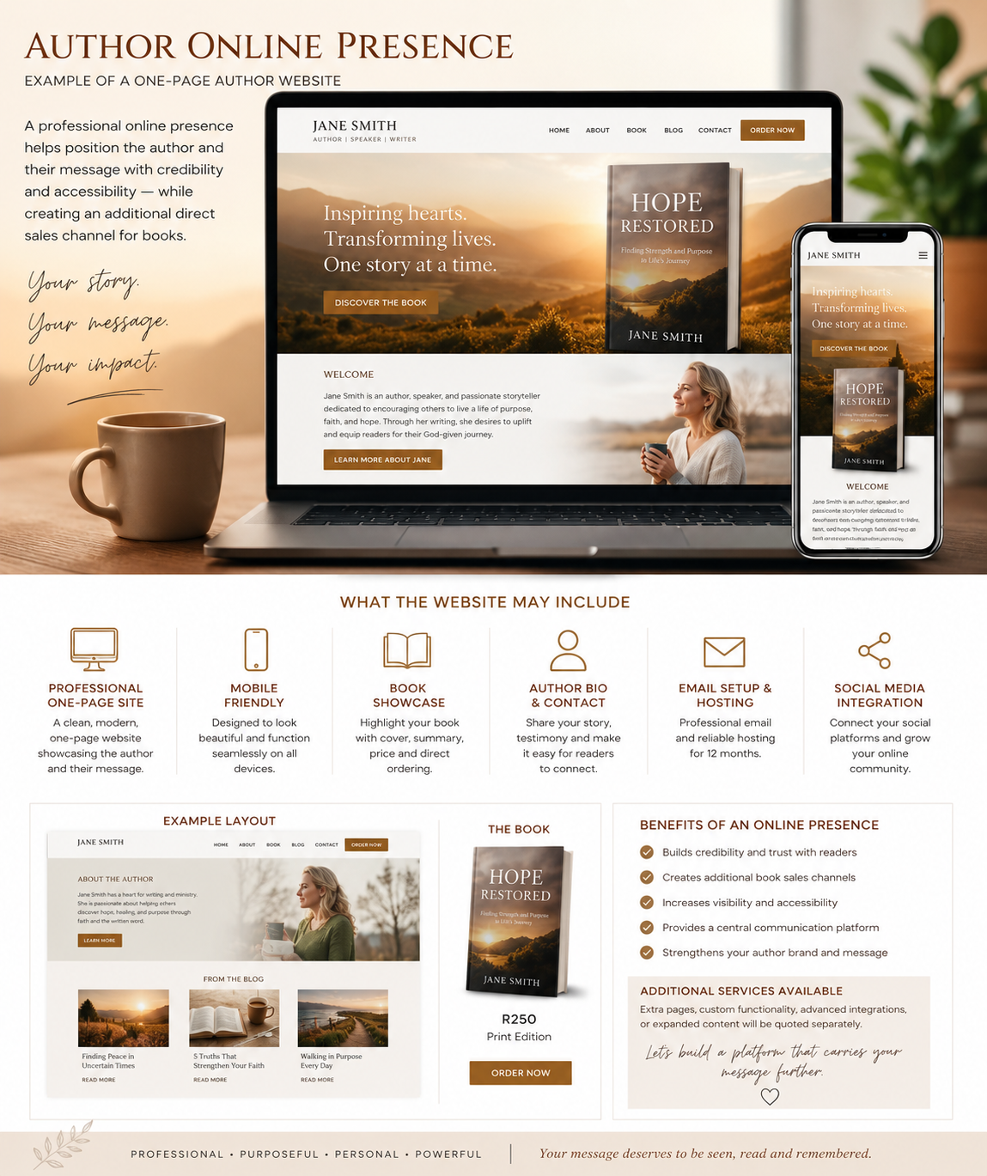

Thank you for entrusting your manuscript to AP Editorial & Publishing Services.

I am looking forward to meeting you and hearing your story.
Amanda Pool

